Headline:
The ABCs and 123s of Variable Frequency Drives

Description:

This document details 50 of the most important variable frequency drive terms that VFD users should understand to specify and maintain their drives more effectively.

Image: WP.AFD.34_ABCs and 123s of VFDs.jpg

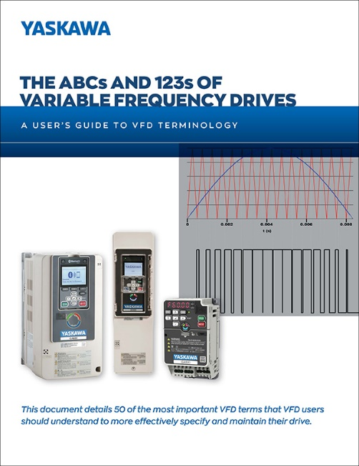

Link to white paper: https://www.yaskawa.com/links?type=documents&docnum=WP.AFD.34&name=

